OCCAR Director at EDA to discuss cooperation and bilateral roadmap

Brussels - 10 December, 2019

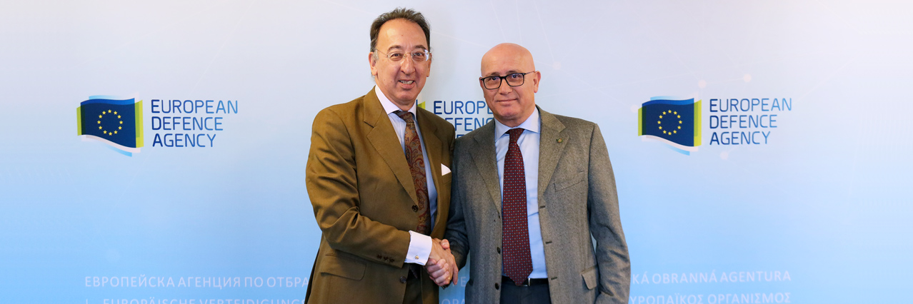

**OCCAR Director Matteo Bisceglia today visited EDA to discuss with Chief Executive Jorge Domecq bilateral cooperation and programmes of relevance to both organisations.**  
EDA-OCCAR cooperation has deepened significantly since the signature of an Administrative Arrangement in 2012. As privileged partners in the field of defence capabilities development, EDA and OCCAR share information on projects and programmes of common interest throughout their lifecycle, helping to guarantee a seamless handover in each case, with both parties remaining involved and informed at every stage.    
  
Today was the second meeting between Mr Bisceglia and Mr Domecq, their discussions mainly focused on the state of play of bilateral cooperation to support key programmes and activities, including the Multi-Role Tanker Transport Fleet (MMF), MALE RPAS and ESSOR. Mr Domecq outlined EDA’s latest developments in these projects, notably the recent high-level coordination mechanism for RPAS ATI held at EDA and updates from the European Secure Software Defined Radio (ESSOR) workshops.    
  
“*I believe that EDA and OCCAR cooperation avoids duplication in the European armament field. We have to take stock and make use of the available resources, and OCCAR has 20 years of proven record in the successful delivery of complex armament programmes.   
  
I am also convinced that together EDA and OCCAR, in line with our own complementary responsibilities, represent a real strong tool to launch and execute all sorts of programmes for the benefit of the European Nations*”, Mr Bisceglia said.     
  
Mr Bisceglia and Mr Domecq also discussed EDA-OCCAR interaction in areas such as REACH and the Military Airworthiness Authorities Forum.       
  
“*EDA and OCCAR are two important actors in European defence cooperation, our close relationship has been extremely positive for our organisations, programmes and defence cooperation in general, which have all benefited from each other’s expertise*”, Mr Domecq commented.